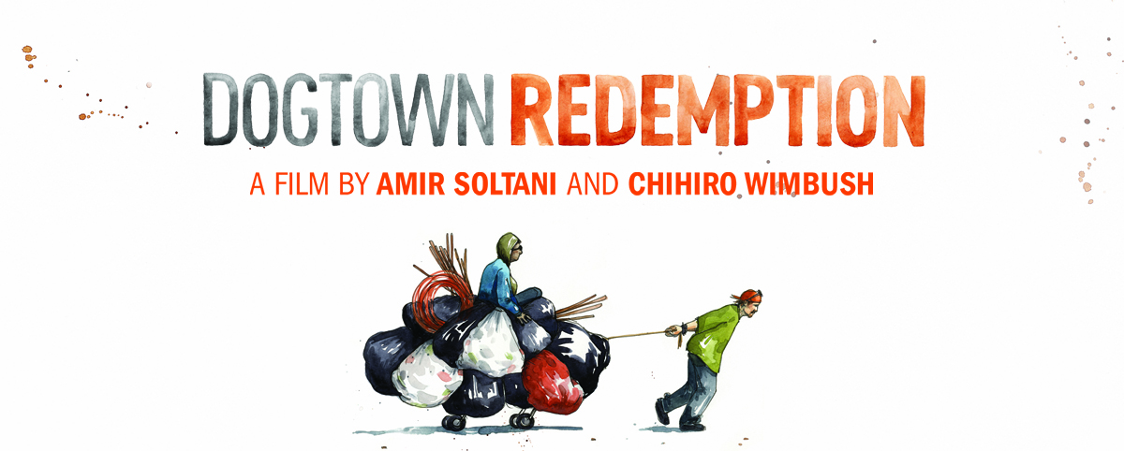

Press Release Template

FOR IMMEDIATE RELEASE
CONTACT: Your name, your organization, your phone number, your email address

New Documentary Portrait of Street Recyclers, Whose Daily Fight to Survive Raises Questions about Race, Class, and the Rights of the Poor Showing at (Venue)
Dogtown Redemption tells the powerful story of recyclers in West Oakland who depend on redeeming trash for survival.

CITY, STATE—On (DAY), (DATE), the (YOUR ORGANIZATION HERE) will host a free (MENTION THIS IF YOU ARE NOT PLANNING TO CHARGE) screening of Dogtown Redemption, a powerful documentary that presents important voices in a conflict over race, class, and space in a modern American city. A surprising number of people make their living off our nation’s vast rivers of trash. They are America’s unseen. Dogtown Redemption follows the lives of three of these people over seven years: Jason Witt, the Olympic champion of recycling, who often hauls a shopping cart that weighs over a ton; Landon Goodwin, a former minister who struggles with his own fall from grace; and Miss Hayok Kay, the daughter of a prominent Korean family and drummer for a 1980s punk band, now at the mercy of the elements and predators. Each survives by redeeming bottles, cans, and assorted other recyclables in an area of West Oakland, California, nicknamed “Dogtown.” Their poignant personal stories reveal the art, science, economics and politics of recycling: what it offers, how it touches the poor, and why it matters to all of us. The film is being shown in community screening venues throughout 2016. It will be released as part of PBS’ Independent Lens series in May 2016.

Every year Californians buy about 22 billion beverages in aluminum, glass, and plastic containers, each of which can be redeemed for a few cents. As a result, trash can be turned into cash, providing a lifeline for a subculture of marginalized recyclers — the unemployed and underemployed, the elderly, the mentally and physically disabled, former criminals, drug addicts, and prostitutes—who, through recycling, earn money and reclaim the pride that comes with having a job. Dogtown Redemption follows Jason, Landon, and Miss Kay through the prism of a single recycling center: Alliance Metals in West Oakland. With annual sales in the millions, Alliance is an anomaly in an otherwise depressed neighborhood that has witnessed the steady flight, erosion, and collapse of American industry. Owner Jay Anast purchases bottles and cans from shopping cart recyclers, turning Alliance into a financial hub and community center for a Fellini-esque cast of characters—the pirates of trash. By virtually any measure, the denizens of the recycling center should be dead. But they defy Darwin—poverty has turned them into masters of improvisation and ingenuity.

Residents of new developments in West Oakland view Alliance Metals as noisy, smelly, and dirty—a giant garbage can that attracts scavengers, drug dealers, and criminals. The rattle of the shopping carts, missing garbage cans, litter on the streets, public defecation, theft, crime, and trespassing are offered as evidence that the recyclers are a blight upon the neighborhood. Dogged by addiction, mental health issues, homelessness, and poverty, the recyclers' grip on life is tenuous. Recycling serves as the only constant in their life. Yet with commodity prices collapsing, neighbors calling for a ban on shopping cart traffic, and Alliance Metals now slated to close in August 2016, their way of life is threatened. The question of who owns our garbage makes these otherwise marginal characters important voices in a conflict over race, class, and space in a modern American city. Dogtown Redemption humanizes and celebrates this other America, one that many of us never see. That a small business has allowed so many to survive on a daily basis—for years, even decades—is a minor miracle.

Amir Soltani is the Producer and Co-Director of Dogtown Redemption. Amir is an Iranian-American human rights activist. He has worked in journalism, philanthropy and business. He is the author of Zahra’s Paradise, a New York Times Bestselling graphic novel on Iran’s 2009 protests. Amir studied history at Tufts and Harvard. Dogtown Redemption is his first documentary film.

Chihiro Wimbush is a hapa, Oakland-based filmmaker. Most recently he served as editor of the award-winning film Changing Season: On the Masumoto Family Farm. With his wife Meena Srinivasan, he creates mindful media and education content via their nonprofit organization, A Lens Inside. Between chasing shopping carts and other stories, Chihiro writes and tries to lure his musical muse out of hiding.

To learn more about Dogtown Redemption, visit DogtownRedemption.com, facebook.com/redemptiondoc, or follow on Twitter at twitter.com/redemptiondoc

If you go:

MONTH, DATE (TIME): CITY, STATE at the VENUE
For more information, (YOUR CONTACT INFORMATION AND/OR WEB ADDRESS)
###

Preview copies of the film for media review are available. Members of the film team are also available for interviews with media. Contact Denise Zmekhol at (415) 378-7436 / denise@zdfilms.com or Lauren Kawana at (808) 386-2565 / lauren.akie@gmail.com for more information.

SHORTER PUBLIC RELATIONS WRITE-UP ON DOGTOWN REDEMPTION SCREENING, FOR LISTING ON CALENDARS OF EVENTS OR WEBSITES

Join us at the (VENUE) for a screening of Dogtown Redemption!
See the powerful documentary that reveals an America overlooked! Dogtown Redemption presents important voices in a conflict over race, class, and space in a modern American city. At the heart of the story is a small recycling center that represents survival for some, a nuisance for others. Dogtown Redemption humanizes an America that goes unseen by many and reminds us that, even in trash, there can be life, love, and redemption.
Now this amazing story is told through Dogtown Redemption, the new, landmark documentary film produced by independent filmmakers Amir Soltani and Chihiro Wimbush.

(ORGANIZATION) is hosting a screening of Dogtown Redemption for the community. Join us!
DATE:
TIME:
LOCATION:
ADDRESS:
TICKETS: (note if free)
MORE INFORMATION: DogtownRedemption.com (also list your own website if you have more information there)

Thank you to our major sponsors:
List any sponsors who have helped you make the event possible

